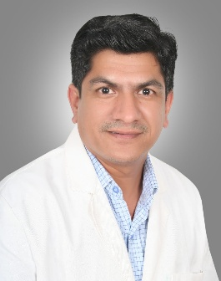
Dr. Ashok Yadav
MSc. Clinical Microbiology | Ph.D. Biotechnology
Healthcare & Diagnostic Laboratory Professional | Quality & Technology Leader | Academic Mentor
Dr. Ashok Yadav is a highly experienced healthcare and diagnostic laboratory professional with over 22 years of experience working with leading pathology and diagnostic laboratories across India. With an MSc. in Clinical Microbiology and a Ph.D. in Biotechnology, he brings a strong combination of scientific expertise, operational leadership, quality management, and a deep understanding of modern diagnostic healthcare.
Over the course of his professional journey, Dr. Yadav has been closely associated with the development and advancement of diagnostic laboratory services, with particular emphasis on quality control, laboratory systems, technological advancement, and efficient patient-centric diagnostic services. His extensive experience enables him to understand the evolving needs of the healthcare industry and translate scientific and technological advancements into practical laboratory solutions.
Dr. Yadav has also been associated with various universities and academic institutions, where he has contributed to the teaching and professional development of healthcare professionals. He has published >10 research publications in national and international reputed journals .He is passionate about sharing his practical knowledge and industry experience with the next generation of healthcare professionals, helping them develop the skills, scientific approach, and professional outlook required to meet the changing demands of the healthcare industry.
He is well versed in quality control and quality management systems, modern laboratory technologies, diagnostic advancements, and contemporary healthcare practices. His leadership philosophy focuses on maintaining high standards of accuracy, reliability, efficiency, and ethical patient care while continuously embracing innovation.
Under his leadership and vision, Micro Path Labs, Gurugram, has grown into a leading pathology and diagnostic laboratory in North India, establishing a reputation for quality, advanced diagnostic services, timely reporting, and professional excellence.
Dr. Yadav continues to work toward strengthening diagnostic healthcare through innovation, quality, technology, education, and development of skilled healthcare professionals, with a vision to make diagnostic services more reliable, accessible, and future-ready.
Core Areas of Expertise
- Clinical Microbiology & Biotechnology
- Diagnostic Laboratory Management
- Quality Control & Quality Management
- Advanced Diagnostic Technologies
- Laboratory Operations & Process Excellence
- Healthcare Professional Training & Mentorship
- Academic Teaching & Industry-Academia Collaboration
- Innovation in Diagnostic Healthcare
- Patient-Centric Laboratory Services
- Strategic Leadership & Organizational Development
Vision
“To build a future-ready healthcare ecosystem by combining scientific excellence, advanced technology, uncompromising quality, and continuous education of the next generation of healthcare professionals.”

